**IEEE**

***Institute of Electrical and Electronic Engineers***

**Joint Akron/Canton Section/Student Branch – The University of Akron/PES**

**Saturday, February 14, 2015**

**Two Transformer Tutorials**

1. **Transformer Design and Design Parameters 10:00 am to Noon (2 CPD Hrs)**

The presentation will be on the Basic of Transformer Design. The presentation will explain how a transformer designer interprets parameters such as MVA, lightning Impulse, Switching impulse, Percentage Impedance supplied by a customer. It will touch on Power rating [MVA], Core, Rated voltages, Insulation Coordination, Short-circuit Impedance, Short-circuit Forces, Loss evaluation, Temperature limits, Cooling, Sound Level etc. It will also explain overload and life expectancy of a transformer as well when Delta winding is needed in Wye-Wye connection. The presentation will answer why in North America we like to regulate from low voltage side whereas in Europe regulates from high voltage side.

1. **Transformer Manufacturing Processes 1:00 pm to 3:00 pm (2 CPD Hrs)**

The presentation will be on the Industry wide manufacturing process to build a transformer in the shop floor. Processes will cover Core Construction, Insulation, Windings, Core and Coil, Processing, Tanking, Testing and Shipping. Some of the hold-points during the processes will be explained as well what a customer should look into while doing factory inspection. The presentation will also cover reconnection both in LV and HV, LTC Tap changer both in tank and separate tank, Lead works.

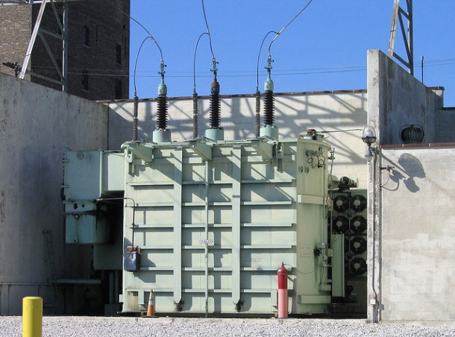

**Speaker: Ronnie Minhaz, P.Eng.**

President, Transformer Consulting Services, Inc.

**Cost: $25 per person per Tutorial (IEEE members)**

**Non-IEEE members - $50**

**(Free to those who join IEEE at the tutorial)**

**Students: IEEE - $5; non-IEEE - $20**

**Location: The University of Akron, Student Union Bldg. Room 312**

**Parking available in the Exchange St. deck off Carroll St.**

**Lunch available at the Student Union (on your own) for those who wish to stay for both tutorials.**

Please contact Rick Buchanan at (330) 497-8250 or [R.Buchanan@ieee.org](mailto:R.Buchanan@ieee.org) for reservations no later than Wednesday, February 11.

(See the upcoming announcement on the tour of the SGB USA\OTC Services in Louisville, OH – Monday, February 16)